# Q1

customerCLASS

string name;

string id;

string chequeID;

double cash;

double loan;

Deposit(double,string); //double = amount string = check for cheque id

Withdraw(double,string); //double = amount string = check for cheque id

ApplyForloan(double,string); //double = amount string = check for cheque id

# Q2

PatientClass

String name;

String id;

String issue;

Emergency(datetime) //pass in date time to save the date time in a string to be pass to issue

Clinicalop(datetime)

Specialist(datetime)

# Q3

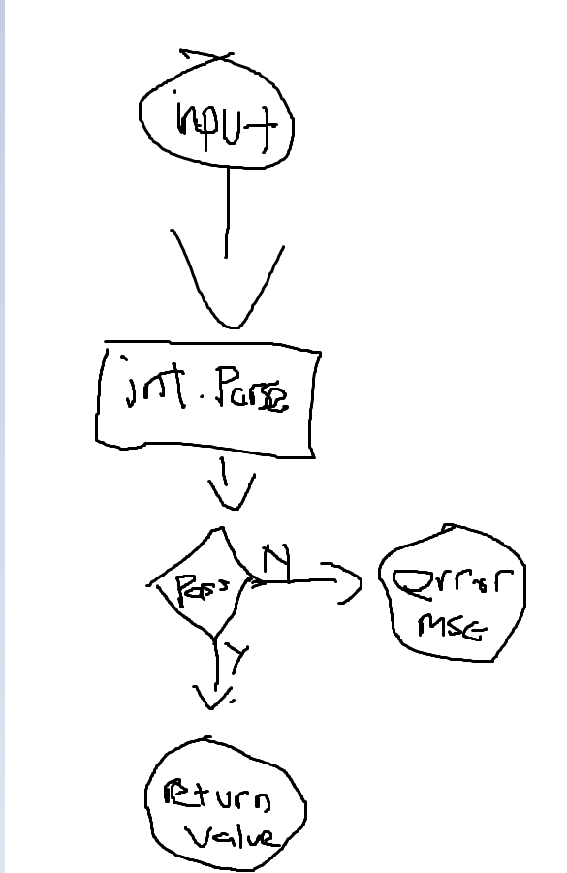

# Q5

TimeClass()

Currenttime()

Internationaltime()